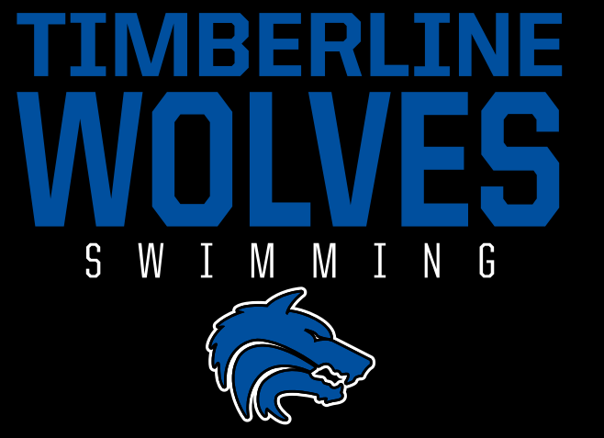
Timberline High School Swim Team – Handout

Interested in Joining the Swim Team?
We’re excited to have you!
Here’s everything you need to know to get started and be ready for the season.

Eligibility & Registration
- Sports Physical Required
  - Required for all incoming 9th graders and 11th graders
  - Must be completed between May 1 – August 1
  - No physical = no participation (you cannot enter the pool until completed)
- Registration
  - All athletes must register through the RankOne platform
  - Step-by-step instructions are available online

Practice Information
- Location: Idaho Central Aquatic Center
3575 S Findley Ave. Boise, ID 83705
- Schedule: Monday – Friday, 6:00 AM – 7:15 AM
- Uniform: Gray caps for practice, Blue for meets, Black for Districts/State
- Adjusted Time:
  - 9th grade swimmers are dismissed at 7:00 AM on school days (for travel time to junior highs)
  - On non-school days, all swimmers stay the full practice

August 10th – First Day of Practice
Meeting after first practice on the turf behind ICAC to go over handbooks
August 12th – First Day of School
October 10th- Homecoming no Meet

Swim Meet Schedule
- Saturday, August 29 – 12:30 Warm up 1:30 PM @ ICAC
- Tuesday, September 1 – 12:30 Warm up 1:30 PM @ WYMCA
- Tuesday, September 15 - 4:30 PM Warm Up 5:30 PM @ WYMCA
- Saturday, September 19 - 8:30 AM Warm up 9:30 AM @ ICAC
- Friday, Saturday September 25,26 Brave Knights invitational @ TBD
- Saturday, October 3 - 4:30 PM Warm Up 5:30 PM @ ICAC
- Tuesday, October 13 - 12:15 Warm up 1:00 PM @ ICAC
- Districts , Tuesday, October 27th-JV morning Varsity Afternoon @ TBD
- State Friday-Saturday November 6-7 @ West YMCA

Additional Resources
- Timberline Athletics Page
- Boise School District Athletics
- Idaho High School Activities Association (Swimming)
Questions?
Contact Coach Danny at:
timberlineswimming@gmail.com

We’re looking forward to a great season—see you at practice!

